Raysync
External HTTP Authentication Documentation

Document Information
Title： | Raysync External HTTP Authentication Documentation
Author | Jay Lin | Version | V6.0
Document Number |  | Version Date | 2024/07/23
Reviewed by： |  | Approved by：

Contents
1. Introduction 4
1.1 Document purpose 4
1.2 Intended Audience 4
1.3 Terminology and Definitions 4
1.4 Scope of Use 5
2.Authentication Types 5
2.1.Controlled by External HTTP Service 5
2.1.1.Description 5
2.1.2.Integration Flowchart 6
2.1.3.Access Steps 6
2.1.3.1.Configuration 6
2.1.3.2.Http Service Interface 7
2.1.3.3.Configure Default Server in Client 11
2.2.Controlled by Raysync 11
2.2.1.Description 11
2.2.2.Access Steps 12
2.2.2.1.Configure 12
2.2.2.2.Http Service Interface 12
2.2.3.Password Encrypotion Description 14
2.2.3.1.Pathyon Example 14
2.2.3.2 Java Example 15

Introduction

1.1 Document purpose
The purpose of this document is to describe and guide the usage scenarios and access specifications for external HTTP authentication in third-party authentication with Raysync.

1.2 Intended Audience
The intended audience for this document includes:
- Project Managers and Architects
- Administrators and Developers of the integrated business systems
- Other project-related personnel

1.3 Terminology and Definitions
Term / Definition ： | Description
External Authentication Service System | A system planned to integrate with Raysync, providing user authentication services.
Business System | An application system developed by users that is planned to integrate with Raysync.

1.4 Scope of Use
This document is applicable to Raysync version 6.8.8.1 and above.

2.Authentication Types

2.1.Controlled by External HTTP Service

2.1.1.Description
The external HTTP authentication service provides user authentication, as well as user storage and user permissions. After successful user authentication, the Raysync system does not create user information synchronously; the external HTTP authentication service needs to maintain user information, user storage, and user permissions.

2.1.2.Integration Flowchart
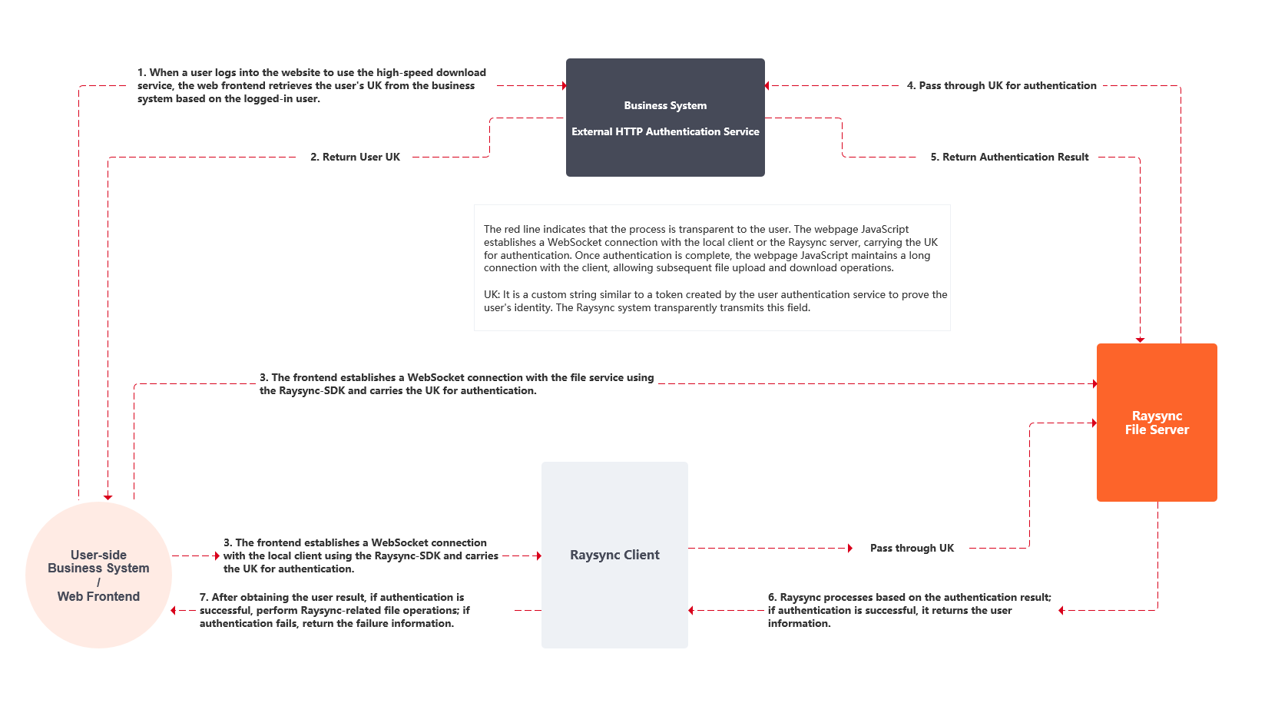

2.1.3.Access Steps

2.1.3.1.Configuration
Modify the authentication method for third-party login in the Raysync backend and fill in the authentication service URL, as shown in the figure below.
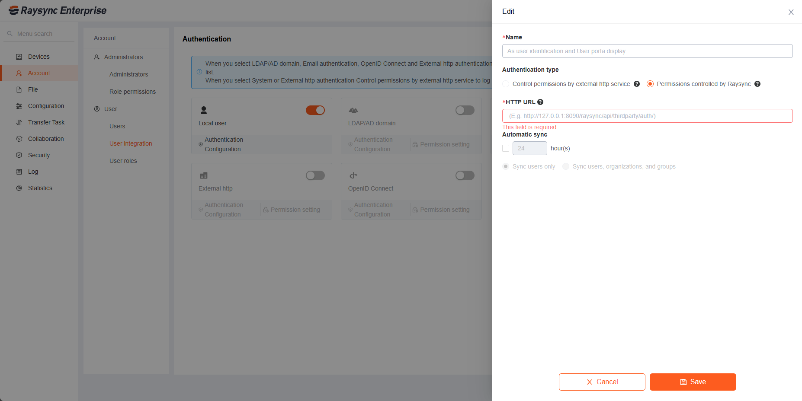

2.1.3.2.Http Service Interface
Interface Name | External HTTP Authentication Raysync User Authentication Interface
Request URL | http://127.0.0.1:8888/raysync/api/thridparty/auth
Request Type | POST
Request Header | uk=”xxxxxx”(uk is a custom token string defined by the user center to prove the user's identity; the Raysync system transparently transmits this field)
Request Example | None
Response Parameters
  Field | Type | Name | Description
  code | int | Response Status Code | The return data code of 0 indicates normal operation; all other codes are considered incorrect.
  msg | string | Response Message | No special requirements.
  data | dict | Response Data
  data_groupList | List | Goup Information List
  data_groupList_groupId | int | User Group ID | For individual users, groupId:0;  for groups, groupId > 0 (indicating the group ID)
  data_groupList_groupName | string | User Group Name | When the user does not belong to any group, groupName: ""
  data_groupList_uploadSpeed | int | Upload Speed Limit | 0 indicates no limit; unit: bytes
  data_groupList_downloadSpeed | int | Download Speed Limit | 0 indicates no limit; unit: bytes
  data_groupList_suffixList | string | Allowed File Extensions for Upload | Semicolon-separated; "" indicates no restrictions
  data_groupList_visable_list | list | Visible File List | If there are no file visibility restrictions, fill this field with []; if there are visibility restrictions, list the required files in a JSON array
  data_groupList_virtual_dir | list | Virtual Directory Fields
  data_groupList_virtual_dir_alias | string | Virtual Directory Alias
  data_groupList_virtual_dir_path | string | Virtual Directory Real Path
  data_groupList_home | string | User's Relative Directory
  data_groupList_permission | dict | User Permissions
  data_groupList_permission_list | bool | Can List Directory
  data_groupList_permission_upload | bool | Can Upload
  data_groupList_permission_download | bool | Can Download
  data_groupList_permission_remove | bool | Can Delete
  data_groupList_permission_rename | bool | Can Rename
  data_groupList_permission_mkdir | bool | Can Create Directory Indicates
  data_userId | int | User ID | Ensure that this ID is unique
Response Message | {  "code": 0,  "data": {  "groupList": [  {  "uploadSpeed": 0,  "downloadSpeed": 0,  "groupId": 0,  "groupName": "aa",  "home": "D:\\work\\raysync",  "permission": {  "download": true,  "list": true,  "mkdir": true,  "remove": true,  "rename": true,  "upload": true  },  "suffixList": "",  "virtual_dir": [],  "visable_list": []  }  ],  "userId": 2  },  "msg": "OK"  }

2.1.3.3.Configure Default Server in Client
1.Enter the correct server address.
2.The username can be entered randomly.
3.Input the UK as the password
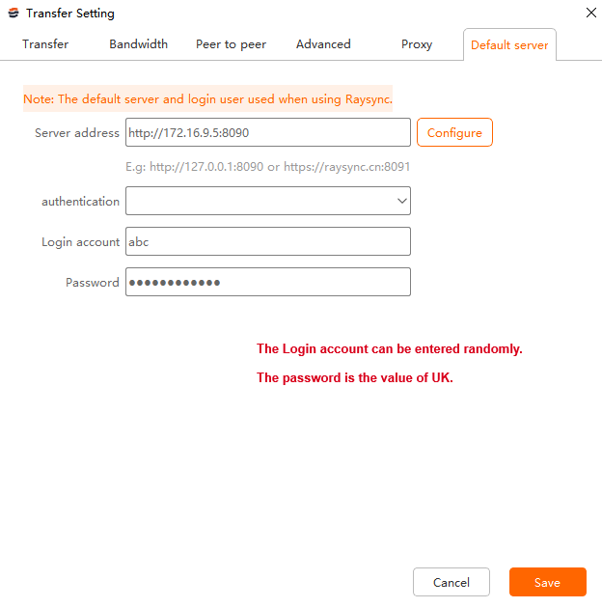

2.2.Controlled by Raysync

2.2.1.Description
The external HTTP authentication service provides user authentication services, which only require the user account and password for validation. After the user logs into the Raysync user portal, the Raysync system will create the user based on this account, and the administrator can configure user permissions in the Raysync backend.
The first method is to use a token carried by the external HTTP authentication system's redirect link to access the Raysync website, for example:
https://raysync.cn:8091?http_token=token
The second method is to log into Raysync using the account and password from the external HTTP system.

2.2.2.Access Steps

2.2.2.1.Configure
Modify the authentication method for third-party login in the Raysync backend and fill in the authentication service URL, as shown in the figure below.
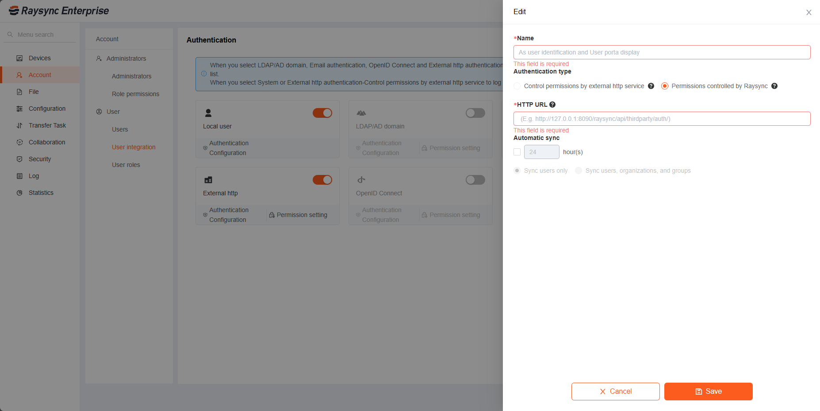

2.2.2.2.Http Service Interface
Interface Name | External HTTP Authentication Raysync User Authentication Interface
Request URL | http://127.0.0.1:8888/raysync/api/thridparty/auth
Request Type | POST
Request Header | Content-Type=“application/json”
Request Parameters | Field | Type | Name | Description
Request Parameters | type | Int | Authentication Type | 1:Token authentication  2: Account password authentication
Request Parameters | token | string | Token | Required when type is 1
Request Parameters | account | string | Account | Required when type is 2
Request Parameters | password | string | Password | Required when type is 2, password needs to be encrypted
Request Example 1 | {  "type": 1,  "token": "QlXmVpPWyb8JYLKABdzQ42kgLBYemGAoYjHaE6DbqjwZeoMD90GRr163xNav5EOo",  }
Request Example 2 | {  "type": 2,  "account": "test",  "password": "2qJlKGPLvQMyO6jN0Z7VARqDzbEJ2l1jr0xiwy1dkeowE5Xnr41gb9xm28pY3BpQ",  }
Response Parameters | Field | Type | Name | Description
Response Parameters | code | Optional | Optional | (Required) 200 for success; other values for errors
Response Parameters | message | string |  | (Optional) Error message
Response Parameters | account | string | User Account | (，Required) Must be unique; displayed as the Raysync account, consistent with login account
Response Parameters | name | string | User Name | Optional
Response Parameters | email | string | User Email | Optional
Response | {  "code": 200,  "data": {  "account": "test",  "name": "name",  "email": "test@xx.com",  }  }

2.2.3.Password Encrypotion Description
Password encryption uses Hashids (Hashids is a small open-source library that generates short, unique, non-sequential IDs from numbers). The salt value is the corresponding account, for example: test. The default length is 64 bits.

2.2.3.1.Pathyon Example
# -*- coding: utf-8 -*-
from hashids import Hashids
import binascii
account = "test"
password = "Aa123456"
hashids = Hashids(salt=account, min_length=64)
# Encoding
b_str = bytes(password, encoding="utf8")
en_str = binascii.hexlify(b_str)
val = str(en_str, encoding="utf-8")
decode_val = hashids.encode_hex(val)
print('decode', decode_val)
# Decoding
s = "2qJlKGPLvQMyO6jN0Z7VARqDzbEJ2l1jr0xiwy1dkeowE5Xnr41gb9xm28pY3BpQ"
val = Hashids(salt=account, min_length=64).decode_hex(s)
_str = bytes(val, encoding="utf8")
output = binascii.unhexlify(_str)
val = str(output, encoding="utf-8")
print("encode", val)

2.2.3.2 Java Example
import org.hashids.Hashids;
// Dependency： hashids JAR 1.0.3
public class Main {
public static void main(String[] args) {
String account = "test";
String password = "Aa123456";
Hashids hashids = new Hashids(account, 64);
byte[] bytes = password.getBytes();
String hexString = bytesToHex(bytes);
String encoded = hashids.encodeHex(hexString);
System.out.println("encoded: " + encoded);
String decodedHex = hashids.decodeHex(encoded);
byte[] decodedBytes = hexToBytes(decodedHex);
String decodedPassword = new String(decodedBytes);
System.out.println("decoded: " + decodedPassword);
}
private static String bytesToHex(byte[] bytes) {
StringBuilder hexString = new StringBuilder();
for (byte b : bytes) {
String hex = Integer.toHexString(0xff & b);
if (hex.length() == 1) {
hexString.append('0');
}
hexString.append(hex);
}
return hexString.toString();
}
private static byte[] hexToBytes(String hex) {
int len = hex.length();
byte[] data = new byte[len / 2];
for (int i = 0; i < len; i += 2) {
data[i / 2] = (byte) ((Character.digit(hex.charAt(i), 16) << 4)
+ Character.digit(hex.charAt(i+1), 16));
}
return data;
}
}

